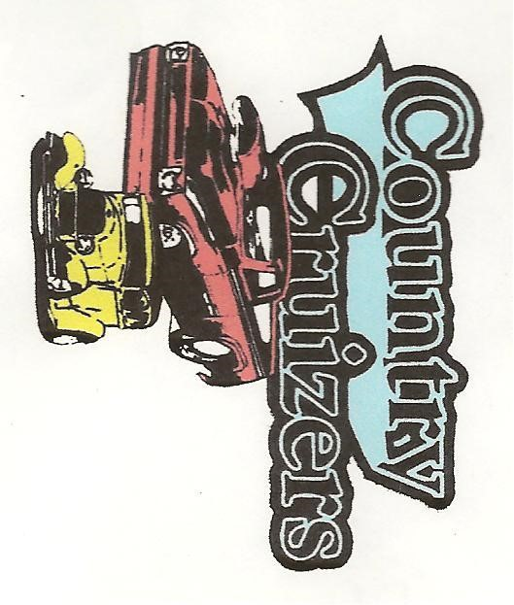
MEMBERSHIP APPLICATION

ANNUAL DUES: [CIRCLE ONE]: SINGLE $10.00 COUPLE: $20
CASH ____________ CHECK # _______________ DATE PAID: _________________
PLEASE PRINT CLEARLY
First Member Name: ________________________________________________ DOB: ___________

Second Member Name: _____________________________________________ DOB: ___________

Mailing Address: ____________________________________________________________________

Email Address: _____________________________________________________________________

Phone Number: ____________________________ Cell Number: ____________________________

Year/Make/Model of Auto(s): __________________________________________________________

__________________________________________________________________________________

I have read, understand and agree to abide by the constitution and bylaws of the Country Cruizers Car Club. I am solely responsible for my actions during club functions.
Signed: ____________________________________________________________________________
___________________________________________________________________________________
MEMBERSHIP DUES ARE VALID STARTING IN JANUARY OF EACH CALENDAR YEAR AND RUNNING THROUGH DECEMBER OF THE SAME CALENDAR YEAR.
PLEASE MAIL DUES AND APPICATION TO:
Country Cruizers Car Club
371 West Lake Road
Oswego New York, 13126

